ContactManagement_Verify Contact notes _Instance44_12-Jul-2018_05-45-03_AM_SingleSignOn.png

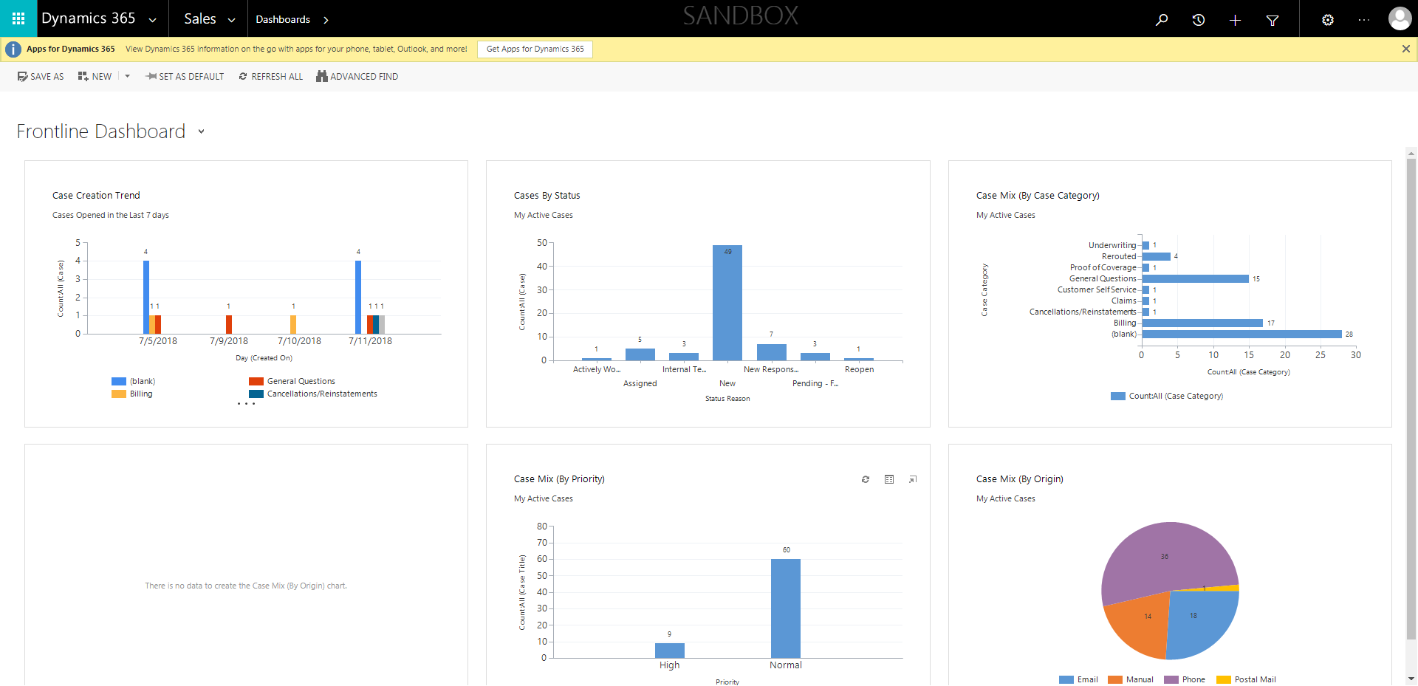

ContactManagement_Verify Contact notes _Instance44_12-Jul-2018_05-44-46_AM_EnterTextAction.png



ContactManagement_Verify Contact notes _Instance44_12-Jul-2018_05-46-16_AM_VerifyingAllNotesofanindividual.png

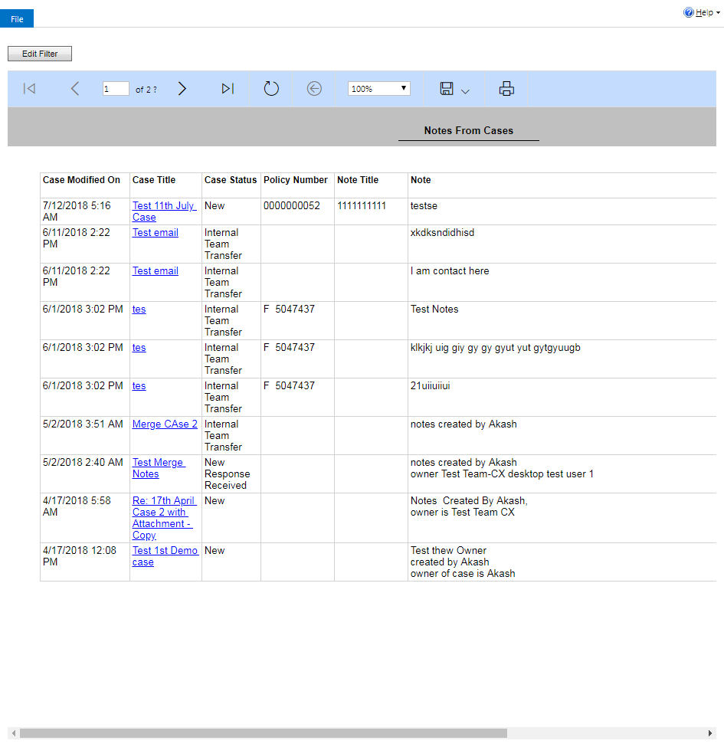

ContactManagement_Verify Contact notes _Instance44_12-Jul-2018_05-46-12_AM_Validatingcontactentitynavigation.png

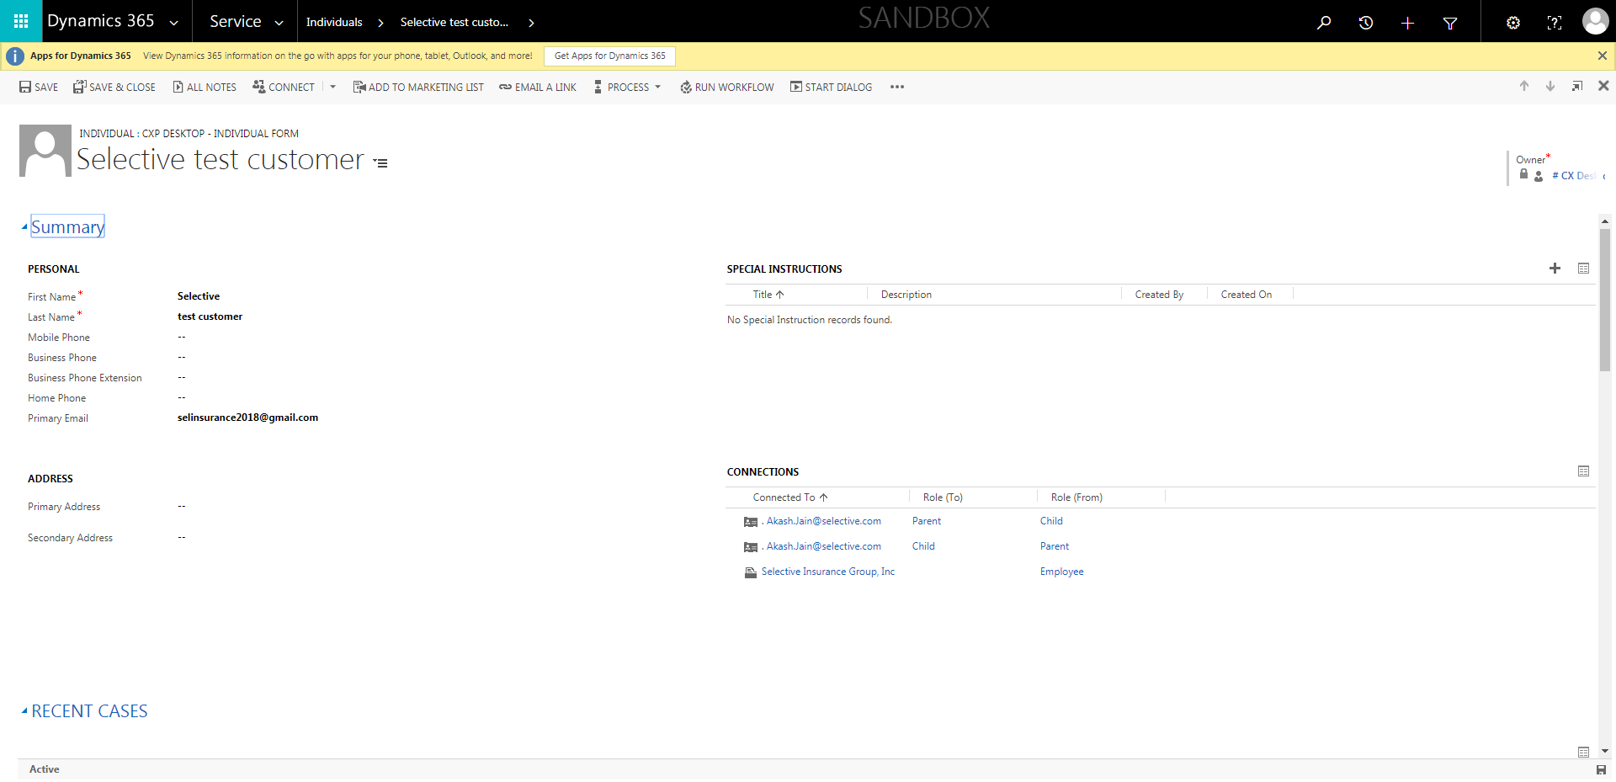

ContactManagement_Verify Contact notes _Instance44_12-Jul-2018_05-44-47_AM_MouseClickActiononStaleElement.png

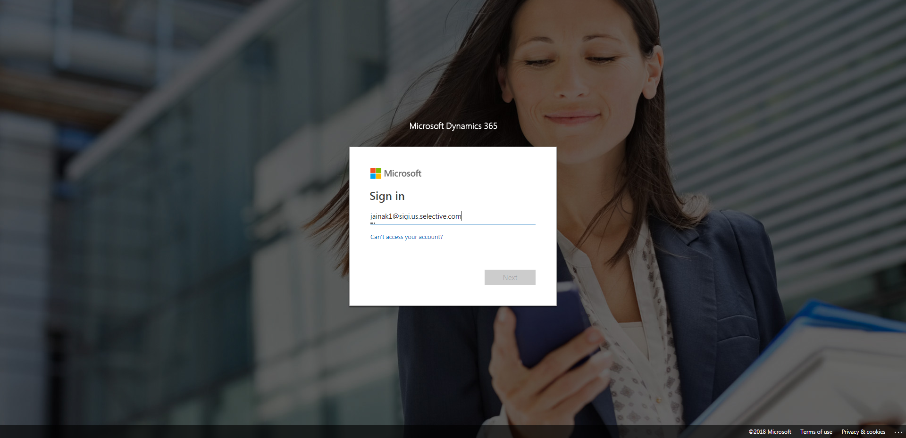

ContactManagement_Verify Contact notes _Instance44_12-Jul-2018_05-44-59_AM_SingleSignOn.png

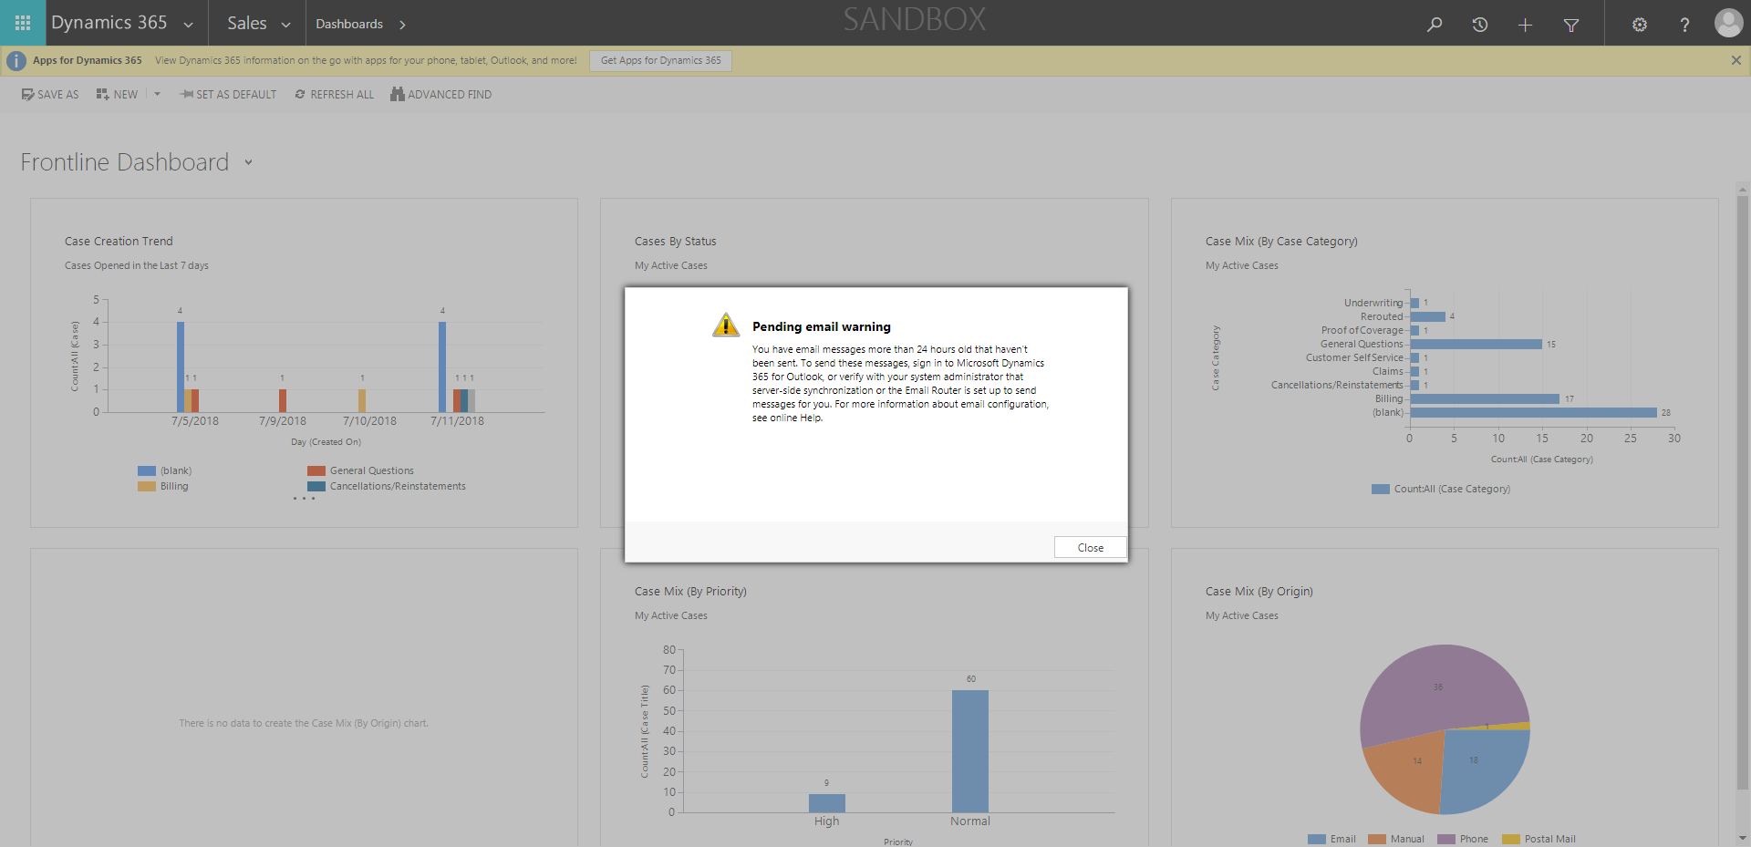

ContactManagement_Verify Contact notes _Instance44_12-Jul-2018_05-44-44_AM_MouseClickActiononStaleElement.png

